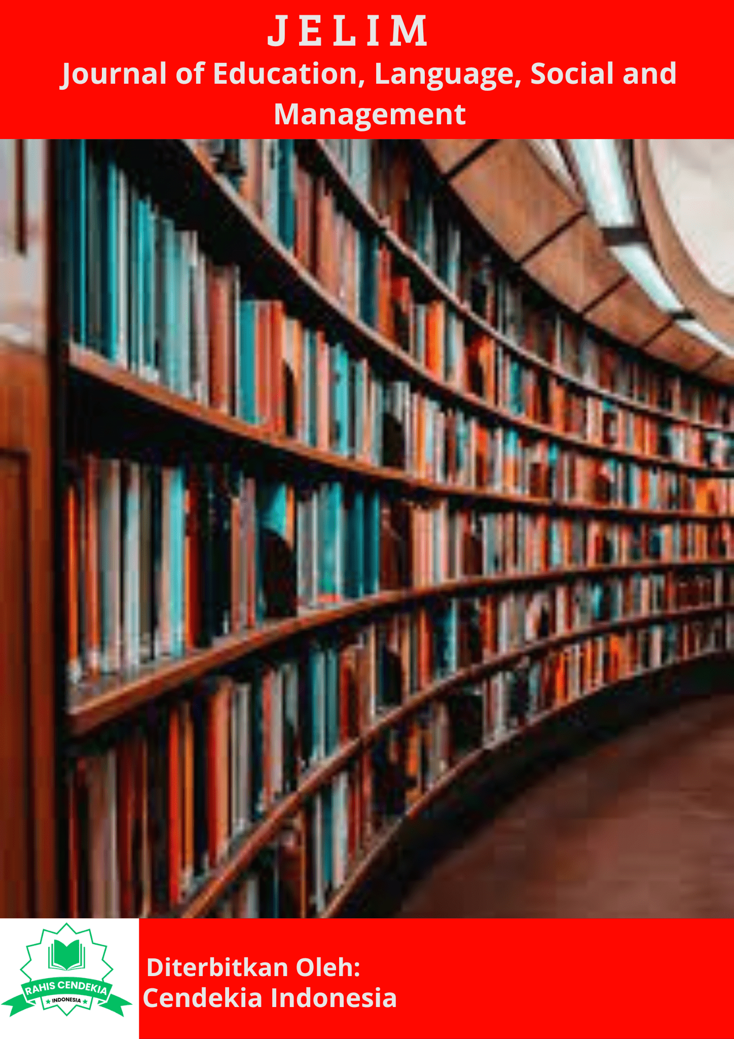

SOCIAL CULTURAL ISSUES AND PROBLEMS IN MI/SD SERANG : SOCIAL STUDIES LEARNING

Muhammad Farizul Umam
¹ Universitas Islam Negeri Banten, Indonesia

Keywords |  | ABSTRACT
Social Culture and Social Studies. |  | The aim of this study is to dig into the trend of globalization, cultural diversity, environmental issues, legal awareness of citizens, cultural pluralism and ethnic diversity in elementary school social science. This method of study belongs to a descriptive analysis study using the method for library research to study and address the issues and social issues of elementary school learning cultures. The data-gathering techniques in this study by locating and gathering data that support the cultural issues and problems of elementary school children's social sciences, both from books and journals. Thereafter, the data obtained was analyzed in order to achieve what was achieved intact and to draw conclusions and answer rules. The result of this study is first, the trend of globalization and the diversity of cultures in Indonesia became the central subject of IPS education regarding issues that people face in the social order of life. Second, environmental issues become the most influential IPS study subjects. Third, citizen legal awareness is appropriate to consider with regard to the application of the law in the lives of citizens especially for trainees who can be accepted as applying it in IPS study. Fourth, cultural pluralism and ethnic diversity are discussions of cultural issues and issues that often arise in society even in small spheres by learners in classes or schools.

INTRODUCTION
Learning is a form of process that almost the entire population of this earth develops in any field. Learning is an activity that must be carried out as a form of process in a better realm. Learning is carried out based on plans that have been compiled according to the formulation and objectives to be achieved. Education has a goal so that learning can focus on creating results and outputs that can follow the progress of education which is increasingly innovating. Education and learning today are always progressing and continuously evaluating in order to achieve what they want to achieve. Teaching and learning in the process is certainly not limited to space and time, but develops widely and unlimitedly. All fields of scientific study also experience growth and continue to lead to progress in order to keep up with the times. The flow of life and human mobility has greatly influenced all processes of the order of life, as well as in the field of education. The world of education is the most important part in the system of human life. Education is presented in various forms and ways as a step to achieve the educational goals that have been formulated previously. One of the fields of scientific study that is important to study is the social and cultural sciences.
The field of social and cultural sciences is part of scientific studies that deal with people's lives in social and cultural relations. The field of social and cultural science is presented in the educational process as the main study that must be involved. Social and cultural sciences in the curriculum in Indonesia are presented in Social Science subjects, or in elementary schools in Thematic subjects in which there is Social Science content. Social studies subjects are given as the main material in all levels of education starting from the elementary to the final level. Basic planting in social studies is very important to be taught from an early age through basic education. Therefore, IPS is a subject that must be poured at the basic level. Social Studies in the current curriculum is part of the main subjects that are presented in an integrated manner with other thematic subjects. The integration of social studies as a social science discipline concept can be linked to the concepts of science, humanities, and various social issues and problems of life. (sapriya : 2009) This social studies subject discusses social and cultural material. The field of science is important because it is directly related to real life and the environment around students. The content and content of social studies subjects are closely related to issues and discussions related to social and cultural problems that occur. Various events that arise and are experienced by a person and even the wider community are related to the existence of social and cultural sciences in social studies learning. These are like social and cultural issues and problems that occur in society. Both of these things often happen in this life and not the least they affect and have an impact narrowly or broadly. Various problems in the form of socio-cultural issues and problems that often occur are usually related to events that often occur in the social sphere of society, one of which is the current trend of modern life such as globalization.
The evidence of the Qur'an explains that all problems in the universe are the will and power of Allah SWT, and no human being will be spared from the problems of life. There is no problem that does not have a solution, so in terms of related problems in social and cultural life in society, it can be studied in depth and together through a scientific view on social studies lessons. Globalization is an internal part of modern life today. Globalization also includes social processes that are not limited by geographical conditions. (waters : 1995) The progress of the global community life order affects social life in a region or country. Order and legal awareness of citizens also take part in issues and socio-cultural issues. Issues and other socio-cultural issues are also about the environment. The environment as a forum for people to carry out their lives often also causes friction between components in it. A community environmental group is also regulated through established laws. The application of legal norms raises awareness in society. The law can bind the community in a national or international scope. These various socio-cultural issues and problems become an influential part of the study of Social Education Sciences (IPS). Social studies subjects presented in the learning process can discuss the various issues above. Students can understand attitudes to deal with and give views on socio-cultural issues and problems that occur. At the elementary level education SD/MI, the discussion of the main issues and problems above can be studied using basic knowledge of social sciences. The educational process can be interpreted with knowledge of the law of cause, effect, and causation. one-mindedness related to the nature and origin of the problem in revealing the values and goals related to the results and steps of the problem as well as issues that have the nature of persistence. (kholisah : 2021) Educators as facilitators in learning play a role in building the character of students who have a strong social spirit. This can be instilled through the learning process, especially in social studies subjects. Teaching and learning activities become a medium or a forum for educators and students to examine the social and cultural issues that occur above. Starting from the writing above, this study will describe in more depth related to sociocultural issues and problems in MI/SD Social Studies learning. The purpose of this study is to explore trends related to globalization, cultural diversity, environmental problems, legal awareness of citizens, cultural pluralism and ethnic diversity in MI/SD Social Studies learning.

METHOD

This research is classified as an analytical descriptive study using the Library Research method to examine and examine socio-cultural issues and problems of MI/SD learning. It aims to examine social issues and problems currently experienced by elementary school students based on the results of the literature. The data collection technique in this study was to find and collect supporting data related to socio-cultural issues and problems in social studies learning for elementary school children, both from books and journals. After that, the data that has been obtained is analyzed in order to get what has been achieved in its entirety and draw conclusions and answer the formulation of the problem.

RESULTS AND DISCUSSION

Globalization Trends and Cultural Diversity in MI/SD Social Studies Learning
Globalization comes from the word global which means the earth or the world. Globalization is a condition where the existing issues or problems concern all citizens and countries to the world's population. Globalization can be interpreted as a form of global community life and interaction. This pattern of interaction influences each other in all aspects of life: political, economic and socio-cultural. According to Anthony Giddens (Giddens : 2003) globalization does not only have an impact on changes that result in homogeneous cross-world or regional relations, but also touches various fields of human life. Indonesian people in their lives influence each other in the fields of social and political science, globalization certainly affects the culture and habits of the people with the inclusion of foreign elements in local culture.
Globalization has an impact in the cultural field which is also reflected in people's attitudes towards determining the form of interaction between themselves and foreign cultures, for example the open attitude of the Sika community towards globalization which is manifested through the introduction of He Gong. Dances and weaving typical of Sikka culture spread to other regions both domestically and internationally. Society accepts the elements of a new attitude that is introduced, and in the process of exchanging or releasing certain cultural elements to be consumed by other cultures, a relationship or reciprocal relationship can be found.(larasati : 2018) According to Paulus Budi Kleden (Kleden : 2012), globalization is "the process of separating certain things from their traditional environment and simultaneously appearing in different regions of the world." Budi Kleden wants to explain that things that used to be very attached to and owned by a certain group of people are now everywhere and can be consumed by anyone. Globalization in the sense of Paulus Budi Kleden is not a one-way process, only the people of Flores consider Western culture as part of their culture, on the contrary the process of globalization is a reality that must be faced. The two definitions above show that globalization has had a major impact on the socio-cultural dimension of society, which is marked by the loss of regional and cultural boundaries. Globalization is seen as having power and speed and has a very high transformative power in all aspects of human life. Therefore, humans must face the new social reality as an inevitable reality.
The pressures of globalization also require each person and certain community groups to leave the comfortable environment of the old world order or socio-cultural structure and switch to a new, more modern, diverse and homogeneous new order. That is, the existence of globalization as a global force requires every individual and group to always adapt and develop on the axis of globalization. In addition, according to Achmad Suparman (Laurensius : 2013) as stated by Laurensius Dihe, globalization is to make something (object or behavior) the property of everyone in the world. without being limited by region. Achmad Suparman explained that globalization is a process that changes the identity of each individual or group that is identical to community groups in other areas. (Mikhael :2017) Globalization has produced an open attitude and has affected all countries and every person and group of people in this country, making them interdependent. In particular, people's behavior or activities in the era of cultural globalization in the arts are always marked by uniformity of taste and perception of artistic creativity, such as dance, woven fabrics and other artistic cultural heritage. Based on the views of scientists, the authors conclude that globalization is a process of integration in various fields of human life that influence each other, causing various changes towards uniformity. Globalization has enormous transformative power in uniting existing diversity into a homogeneous world. Meanwhile, people who accept the reality of globalization as a necessity, show that the transformation process that occurs in globalization indirectly contains an element of coercion, thus causing dependence on the global community. Global education is a forum for students to understand the meaning that they are one of the people on this earth, even though it does not reduce that they are citizens of a country. A good citizen of course must be able to be a good citizen in the eyes of the world, not to create issues and problems that are global in nature. The following are examples of global issues and problems in social studies learning:
- The energy crisis is like the supply of oil.
- Dense population resulting in the spread of disease, and poverty.
- Population
- Nuclear war
- International trade
- Communication
- Drug trafficking.
Education has a big role in building, fostering, and developing human resources which are carried out in a structured, systematic and programmed manner.( Maunah : 2015) Education is required to be linked to research related to cause and effect and related to global issues. All students are required to understand the things that affect and are influenced by these issues and problems. so, it is hoped that they can contribute to the completion process. Diversity can be understood as a process, method or making a variety of cultural issues that develop. Community life has many backgrounds such as religion, ethnicity, and race. The existence of different groups of course also results in conflict. This is based on the socio-cultural background that drives various negative values to emerge. The diversity of the various tribes results in misunderstandings and causes conflicts.( Widiastuti : 2013) Cultural diversity can be introduced since elementary school age, starting with introducing the differences that are owned by one classmate. (Junanah :2020) As well, differences in gender, background, point of view in thinking, and others. Thematic learning of social studies content will be interesting if it is packaged as attractively as possible by the teacher in terms of delivery or learning. students are asked to explore differences, but without doing together the habits that cause issues as well as problems.

Environmental Problems in MI/SD Social Studies Learning
Environmental education is integrated into school subjects, and environmental education can be implemented through an interdisciplinary approach. (Barlia : 2008) Social Studies is one of the subjects taught from primary to final education. Environmental learning through social studies learning can be done by studying global issues. (Sapriya : 2011) Social studies learning in elementary schools in the environmental realm adapts to the objectives of social studies learning, students are expected to be able to think critically and be able to solve social problems and care for the environment such as global warming, floods and others.( Afandi : 2013) Learners in the initial concept in the learning process of the introduction of knowledge in the cognitive realm as well as in the new things they get. Concept maps can make it easier for teachers when planning the learning process.

Citizens' Legal Awareness in MI/SD Social Studies Learning
Every human being needs a process of interaction and relationship with other humans. The interaction process gives rise to several types of environmental conditions that must be faced by social humans. The environmental conditions in question are the physical or natural environment and the social or community environment. The physical environment is the process of human interaction in utilizing the natural surroundings such as land, mountains, oceans, forests, rivers and others. While the social environment is the process of human interaction with other humans within the scope of society such as human relations with the home environment, neighbors, and others. Humans will carry out the relationship process with the natural and social environment dynamically. This makes a group of humans need a set of rules and laws that govern their lives. The process of interaction in a group of people, commonly referred to as the community, is bound by several applicable legal rules so that through these laws there will be a rhythmic relationship between society and nature as well as social life. Then a legal society is formed which in its life is regulated by the implementation of a jointly established law. Enforcement of the law in a society will lead to a good order of community life as a form of social value in society (Rosana : 2014). The applicable law has a meaning that must be applied by individuals in a social order so that awareness is formed which can be measured as the level of legal awareness. Instilling a sense of legal awareness has an important role so that people can understand and obey the law as a result of a sense of legal awareness. It aims to regulate people's lives so that social life is established in a safe and peaceful manner. Therefore, legal awareness is important to be instilled so that people can be aware and always obey the provisions and legal rules that have been enforced in people's daily lives. Legal stipulations that are binding on every member of the community can consciously help to shape the attitudes of people who have legal awareness. (Sariyatun : 2020) The legal awareness that is expected to be formed in the community can be seen from how it knows the behavior that is the right and obligation as well as between something that is recommended and prohibited based on the law that has been ratified. In addition, legal awareness can create a sense of responsibility from individuals to maintain the nobility of the applicable legal values. Students who are also part of the community have duties as agents of change and agents of control (agents of change and control agents) in the social life of the community. Students have a big role with the contribution of critical thinking in the implementation of the applicable law. (Kenedi : 2015) The enactment of the law is related to the democratic system adopted in Indonesia. Students also play a role as a driving force for legal and democratic changes in society. Moving on to the nation's problems in the field of law today, the participation of students to continue to criticize and supervise the passage of the law is very vital today when the law begins to erode little by little. So it is necessary to instill legal awareness as well as possible in students. This effort can be realized through education, because education is a propaganda tool in inculcating the values and character of citizens in the most effective knowledge of law. (Widja : 2002) Therefore, it is necessary to develop a learning design that accommodates the cultivation of the character of students who are aware of the law. Materials in the context of social studies education have the opportunity to be re-explored as materials for learning the values of legal awareness. Legal awareness is an attitude of understanding legal values that must be concreted in concrete actions by individuals and society. The value of the law can be embedded in humans so that it can foster enthusiasm to implement the rules of law that are already in effect and hope to bring laws that do not yet exist to be presented.

CONCLUSION
The conclusion contains a summary of research results in the form of the development of Islamic education science. The conclusions answer the research problem as well as the research objectives. Based on the explanation above, it can be concluded as follows. First, the trend of globalization and cultural diversity in Indonesia is a central subject in social studies learning in relation to issues faced by society in the order of social life.

REFERENCE
Afandi, Rifki. “Integrasi Pendidikan Lingkungan Hidup Melalui Pembelajaran IPS di Sekolah Dasar sebgai Alternatif Menciptakan Sekolah Hijau”. Jurnal Pedagogia, No. 1, Vol. 2, (2013). http://ojs.umsida.ac.id/index.php/pedagogia/article/view/50.
Angraini, Rita. Dkk. “Meningkatkan Kesadaran Hukum melalui Pembelajaran Ilmu Hukum di Perguruan Tinggi. Jurnal Of Civic Education, No. 3, Vol. 1 (2018). DOI: https://doi.org/10.24036/jce.v1i3.249.
Barlia, Lily. Teori Pembelajaran Lingkungan Hidup di Sekolah Dasar. Subang: Royyan Press.2008. Budi, Paulus. Teologi Terlibat. Maumere: Penerbit Ledalero. 2012.
Departemen Agama Republik Indonesia. Al-Qur’an dan Tafsirnya (Edisi yang Disempurnakan). Jakarta: Lentera
Abadi. 2010
Dihe, Laurensius. Sakramen Tobat Di Tengah Globalisasi. Yogyakarta: Kanisius. 2013.
Dua, Mikhael. “Globalisasi Ekonomi, Budaya Kapitalis, dan Demokrasi”. Jurnal Ledalero. No. 2, Vol. 12. (2017). http://ejurnal.stfkledalero.ac.id/index.php/JLe/article/download/97/81. Fitria, Ria. dan Maunah, Binti. “Evaluasi Pembina Kinerja Guru”, Jurnal Joiem, No. 2, Vol. 1, No. 2, (2020), https://jurnal.iainkediri.ac.id/index.php/joiem/article/download/2209/1126.
Giddens, Anthony. Run A Way: Bagaimana Globalisasi Merombak Kehidupan Kita. penerj. Andry Kristiawan S. dan Yustina Koen S. Jakarta: Gramedia Pustaka Utama. 2003.
Iqbal, Muhammad. dan Junanah. “Muhammad: Lelaki Penggenggam Hujan Sebagai Sumber Belajar Afektif Sejarah dan Kebudayaan Islam”. Ta’alum: Jurnal Pendidikan Islam, No. 2, Vol 8 (2020), DOI: https://doi.org/10.21274/taalum.2020.8.2.181-201.
Kenedi, John. “Studi Analisis Terhadap Nilai-Nilai Kesadaran Hukum Dalam Pendidikan Kewarganegaraan (Civic Education) di Perguruan Tinggi Islam”. Jurnal Kajian Keislaman: Madania. No. 2, Vol. 19, (2015). https://scholar.google.co.id/citations/user.
Kholisah, dkk. “Isu dan Permasalahan Sosial Budaya dalam Pembelajaran IPS SD” https://www.academia.edu/37001726/ Isu_dan_Permasalahan_Sosial_Budaya _dalam_Pembelajaran_Ips_SD. (diakses 02 Juni 2021)
Larasati, Dinda. “Globalisasi Budaya dan Identitas: Pengaruh dan Eksitensi Hallyu (Korean Wave) Versus Westernisasi di Indonesia”. Jurnal Hubungan Internasional. No. 1, Vol 1 (2018). https://e-journal.unair.ac.id/JHI/article/download/8749/5697.
Maunah, Binti. “Lembaga pendidikan Islam di Indonesia: Kajian Deskripsi Analitik Model Lembaga Pendidikan Islam”. Jurnal Empirisma, No. 2, Vol. 24 (2015). https://jurnal.iainkediri.ac.id/index.php/empirisma/article/view/23.

